Date : 21/08/2020

**Practial No 1**

**AIM:** WAP in Java to implement the following Substitution Cipher Techniques.

**CODE**

1. **Caesar cipher :-**

|  |
| --- |
| package javaapplicationins; import java.io.*;  import java.util.Scanner; public class CaesarCipher  {  public static void main(String[] args)  {  CaesarCipher c=new CaesarCipher(); Scanner s= new Scanner(System.in); System.out.println("Performed by krunal 713"); System.out.println("Input Data to encrypt"); String str=s.nextLine(); System.out.println("Input the key");  int key=s.nextInt();  String encrypted=c.encrypt(str,key); System.out.println("Encrypted Data:"+encrypted); String decrypted=c.decrypt(encrypted,key); System.out.println("Decrypted Data:"+decrypted);  }  String encrypt(String str,int key)  {  String encrypted="";  for(int i=0;i<str.length();i++)  {  int c=str.charAt(i); if(Character.isUpperCase(c))  {  c=c+key; if(c>'Z'){  c=c-26;  }  }  if(Character.isLowerCase(c))  {  c=c+key; if(c>'z'){ c=c-26;  }  }  encrypted +=(char) c;  }  return encrypted;  }  String decrypt(String str,int key)  {  String decrypted="";  for(int i=0;i<str.length();i++)  {  int c=str.charAt(i); if(Character.isUpperCase(c))  {  c=c-key; if(c <'A'){  c=c+26;  }  }  if(Character.isLowerCase(c))  {  c=c- key; if(c <'a'){  c = c + 26;  }  }  decrypted += (char) c;  }  return decrypted;  }  } |

**Output:**

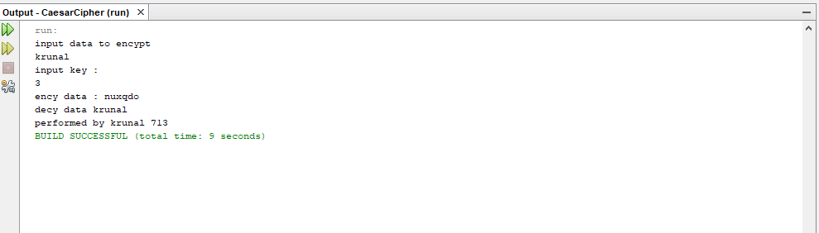

**B)Monoalphabetic Cipher**

**Program code:**

|  |
| --- |
| package javaapplicationins; import java.io.*;  import java.util.Scanner;  public class MonoalphabeticCipher {  public static char p[]={'a','b','c','d','e','f','g','h','i','j','k','l','m','n','o',  'p','q','r','s','t','u','v','w','x','y','z'};  public static char ch[]={'Q','W','E','R','T','Y','U','I','O','P','A','S','D','F','G',  'H','J','K','L','Z','X','C','V','B','N','M'};  public static String doEncryption(String s)  {  char c[]=new char[(s.length())]; for (int i=0;i<s.length();i++)  {  for(int j=0;j<26;j++)  {  if(p[j]==s.charAt(i))  {  c[i]=ch[j]; break; }  }  }  return(new String(c));  }  public static String doDecryption(String s)  {  char pt[]=new char[(s.length())]; for (int i=0;i<s.length();i++)  {  for(int j=0;j<26;j++)  {  if(ch[j]==s.charAt(i))  {  pt[i]=p[j]; break; }  }  }  return(new String(pt));  }  public static void main(String args[])  {  Scanner sc=new Scanner(System.in); System.out.println("Performed by krunal 713"); System.out.println("Enter the message:");  String en=doEncryption(sc.next().toLowerCase());  System.out.println("Encrypted message:"+en); System.out.println("Decrypted message:"+doDecryption(en));  sc.close();  }  } |

**Output:**

